Table 1: RF & XGB top 100 selected features evaluation on BitterEN classifier model
Selection types | Evaluation metrics | ways | BitterEN | Selection types | Evaluation metrics | ways | BitterEN
RF  Analysis | Accuracy | Mean | 0.981 | XGB  features | Accuracy | Mean | 0.966
 |  | Median | 0.984 |  |  | Median | 0.968
 |  | Max | 0.992 |  |  | Max | 0.992
 | Kappa | Mean | 0.963 |  | Kappa | Mean | 0.932
 |  | Median | 0.968 |  |  | Median | 0.937
 |  | Max | 0.984 |  |  | Max | 0.984
 | precision | Mean | 0.980 |  | precision | Mean | 0.976
 |  | Median | 0.984 |  |  | Median | 0.976
 |  | Max | 1.00 |  |  | Max | 1.00
 | Sensitivity | Mean | 0.982 |  | Sensitivity | Mean | 0.955
 |  | Median | 0.984 |  |  | Median | 0.960
 |  | Max | 1.00 |  |  | Max | 1.00
 | Specificity | Mean | 0.980 |  | Specificity | Mean | 0.977
 |  | Median | 0.984 |  |  | Median | 0.976
 |  | Max | 1.00 |  |  | Max | 1.00
 | MCC | Mean | 0.963 |  | MCC | Mean | 0.933
 |  | Median | 0.968 |  |  | Median | 0.937
 |  | Max | 0.984 |  |  | Max | 0.984

Table 2: RF & XGB top 150 selected features evaluation on BitterEN classifier model
Selection types | Evaluation metrics | ways | BitterEN | Selection types | Evaluation metrics | ways | BitterEN
RF  Analysis | Accuracy | Mean | 0.992 | XGB  Analysis | Accuracy | Mean | 0.969
 |  | Median | 0.992 |  |  | Median | 0.968
 |  | Max | 1.00 |  |  | Max | 0.992
 | Kappa | Mean | 0.984 |  | Kappa | Mean | 0.938
 |  | Median | 0.984 |  |  | Median | 0.937
 |  | Max | 1.00 |  |  | Max | 0.984
 | precision | Mean | 0.997 |  | precision | Mean | 0.980
 |  | Median | 1.00 |  |  | Median | 0.983
 |  | Max | 1.00 |  |  | Max | 0.984
 | Sensitivity | Mean | 0.986 |  | Sensitivity | Mean | 0.956
 |  | Median | 0.984 |  |  | Median | 0.968
 |  | Max | 1.00 |  |  | Max | 1.00
 | Specificity | Mean | 0.997 |  | Specificity | Mean | 0.981
 |  | Median | 0.984 |  |  | Median | 0.984
 |  | Max | 1.00 |  |  | Max | 0.984
 | MCC | Mean | 0.984 |  | MCC | Mean | 0.938
 |  | Median | 0.984 |  |  | Median | 0.937
 |  | Max | 1.00 |  |  | Max | 0.984

Table 3: RF & XGB top 200 selected features evaluation on BitterEN classifier model
Selection types | Evaluation metrics | ways | BitterEN | Selection types | Evaluation metrics | ways | BitterEN
RF  Analysis | Accuracy | Mean | 0.992 | XGB  Analysis | Accuracy | Mean | 0.991
 |  | Median | 0.992 |  |  | Median | 0.992
 |  | Max | 1.00 |  |  | Max | 1.00
 | Kappa | Mean | 0.984 |  | Kappa | Mean | 0.985
 |  | Median | 0.984 |  |  | Median | 0.984
 |  | Max | 1.00 |  |  | Max | 1.00
 | precision | Mean | 0.997 |  | precision | Mean | 0.993
 |  | Median | 1.00 |  |  | Median | 1.00
 |  | Max | 1.00 |  |  | Max | 1.00
 | Sensitivity | Mean | 0.986 |  | Sensitivity | Mean | 0.992
 |  | Median | 0.984 |  |  | Median | 1.00
 |  | Max | 1.00 |  |  | Max | 1.00
 | Specificity | Mean | 0.997 |  | Specificity | Mean | 0.993
 |  | Median | 0.984 |  |  | Median | 1.00
 |  | Max | 1.00 |  |  | Max | 1.00
 | MCC | Mean | 0.984 |  | MCC | Mean | 0.986
 |  | Median | 0.984 |  |  | Median | 0.984
 |  | Max | 1.00 |  |  | Max | 1.00

Table 4: RF & XGB top 250 selected features evaluation on BitterEN classifier model
Selection types | Evaluation metrics | ways | BitterEN | Selection types | Evaluation metrics | ways | BitterEN
RF  Analysis | Accuracy | Mean | 0.992 | XGB  Analysis | Accuracy | Mean | 0.971
 |  | Median | 0.992 |  |  | Median | 0.976
 |  | Max | 1.00 |  |  | Max | 0.992
 | Kappa | Mean | 0.985 |  | Kappa | Mean | 0.943
 |  | Median | 0.984 |  |  | Median | 0.953
 |  | Max | 1.00 |  |  | Max | 0.984
 | precision | Mean | 0.990 |  | precision | Mean | 0.965
 |  | Median | 0.984 |  |  | Median | 0.969
 |  | Max | 1.00 |  |  | Max | 0.984
 | Sensitivity | Mean | 0.995 |  | Sensitivity | Mean | 0.978
 |  | Median | 1.00 |  |  | Median | 0.984
 |  | Max | 1.00 |  |  | Max | 1.00
 | Specificity | Mean | 0.990 |  | Specificity | Mean | 0.965
 |  | Median | 0.984 |  |  | Median | 0.968
 |  | Max | 1.00 |  |  | Max | 0.984
 | MCC | Mean | 0.984 |  | MCC | Mean | 0.943
 |  | Median | 0.984 |  |  | Median | 0.953
 |  | Max | 1.00 |  |  | Max | 0.984

Table 5: Performance evaluation of the BitterEN classifier model on individual train-test splits, Cross-validation [k=5], utilizing the top 300 features selected by the RF.
Metrics | Ways | Train | Test | Cross-Validation
Accuracy | Mean | 0.998 | 0.997 | 0.994
 | Median | 1.00 | 1.00 | 1.00
 | Max | 1.00 | 1.00 | 1.00
Kappa | Mean | 0.998 | 0.995 | 0.998
 | Median | 1.00 | 1.00 | 1.00
 | Max | 1.00 | 1.00 | 1.00
Precision | Mean | 0.998 | 0.998 | 0.993
 | Median | 1.00 | 1.00 | 1.00
 | Max | 1.00 | 1.00 | 1.00
Sensitivity | Mean | 1.00 | 0.997 | 0.996
 | Median | 1.00 | 1.00 | 1.00
 | Max | 1.00 | 1.00 | 1.00
Specificity | Mean | 0.998 | 0.998 | 0.992
 | Median | 1.00 | 1.00 | 1.00
 | Max | 1.00 | 1.00 | 1.00
MCC | Mean | 0.998 | 0.995 | 0.998
 | Median | 1.00 | 1.00 | 1.00
 | Max | 1.00 | 1.00 | 1.00

Table 6: XGB top 300 selected features evaluation on BitterEN classifier model
Selection types | Evaluation metrics | ways | BitterEN
XGB feature selection | Accuracy | Mean | 0.969
 |  | Median | 0.968
 |  | Max | 0.992
 | Kappa | Mean | 0.939
 |  | Median | 0.937
 |  | Max | 0.984
 | precision | Mean | 0.970
 |  | Median | 0.969
 |  | Max | 1.00
 | Sensitivity | Mean | 0.968
 |  | Median | 0.968
 |  | Max | 1.00
 | Specificity | Mean | 0.970
 |  | Median | 0.968
 |  | Max | 1.00
 | MCC | Mean | 0.939
 |  | Median | 0.968
 |  | Max | 0.992

Table 7: RF & XGB top 350 selected features evaluation on BitterEN classifier model
Selection types | Evaluation metrics | ways | BitterEN | Selection types | Evaluation metrics | ways | BitterEN
RF  Analysis | Accuracy | Mean | 0.997 | XGB  Analysis | Accuracy | Mean | 0.969
 |  | Median | 1.00 |  |  | Median | 0.968
 |  | Max | 1.00 |  |  | Max | 0.992
 | Kappa | Mean | 0.995 |  | Kappa | Mean | 0.939
 |  | Median | 1.00 |  |  | Median | 0.937
 |  | Max | 1.00 |  |  | Max | 0.984
 | precision | Mean | 0.998 |  | precision | Mean | 0.968
 |  | Median | 1.00 |  |  | Median | 0.969
 |  | Max | 1.00 |  |  | Max | 1.00
 | Sensitivity | Mean | 0.997 |  | Sensitivity | Mean | 0.970
 |  | Median | 1.00 |  |  | Median | 0.968
 |  | Max | 1.00 |  |  | Max | 1.00
 | Specificity | Mean | 0.998 |  | Specificity | Mean | 0.968
 |  | Median | 1.00 |  |  | Median | 0.968
 |  | Max | 1.00 |  |  | Max | 1.00
 | MCC | Mean | 0.995 |  | MCC | Mean | 0.939
 |  | Median | 1.00 |  |  | Median | 0.937
 |  | Max | 1.00 |  |  | Max | 0.984

Table 8: BitterEN [MLP classifier model’s] distinct layer-wise performance.
Number of layers | Accuracy | MCC | Kappa | Precision | Recall | F1 | Sensitivity | Specificity
10 | 1.00 | 1.00 | 1.00 | 1.00 | 1.00 | 1.00 | 1.00 | 1.00
20 | 1.00 | 1.00 | 1.00 | 1.00 | 1.00 | 1.00 | 1.00 | 1.00
30 | 1.00 | 1.00 | 1.00 | 1.00 | 1.00 | 1.00 | 1.00 | 1.00
40 | 1.00 | 1.00 | 1.00 | 1.00 | 1.00 | 1.00 | 1.00 | 1.00
50 | 1.00 | 1.00 | 1.00 | 1.00 | 1.00 | 1.00 | 1.00 | 1.00
60 | 0.992 | 0.984 | 0.984 | 1.00 | 0.984 | 0.992 | 0.984 | 1.00
70 | 0.992 | 0.984 | 0.984 | 1.00 | 0.984 | 0.992 | 0.984 | 1.00
80 | 0.992 | 0.984 | 0.984 | 1.00 | 0.984 | 0.992 | 0.984 | 1.00
90 | 0.984 | 0.968 | 0.964 | 0.984 | 0.984 | 0.984 | 0.984 | 0.988
100 | 0.992 | 0.984 | 0.984 | 0.984 | 1.00 | 0.992 | 1.00 | 0.984

Table 9: AAC applied performances
Selection types | Evaluation metrics | ways | ADA | ETC | RF | KNN | BitterEN
Independent test | Accuracy | Mean | 0.828 | 0.906 | 0.876 | 0.764 | 0.801
 |  | Median | 0.828 | 0.906 | 0.878 | 0.765 | 0.804
 |  | Max | 0.828 | 0.906 | 0.882 | 0.773 | 0.804
 | Kappa | Mean | 0.657 | 0.812 | 0.753 | 0.529 | 0.601
 |  | Median | 0.657 | 0.812 | 0.757 | 0.532 | 0.609
 |  | Max | 0.657 | 0.812 | 0.765 | 0.547 | 0.609
 | precision | Mean | 0.785 | 0.890 | 0.856 | 0.733 | 0.791
 |  | Median | 0.785 | 0.890 | 0.860 | 0.735 | 0.791
 |  | Max | 0.785 | 0.890 | 0.861 | 0.746 | 0.793
 | Sensitivity | Mean | 0.887 | 0.919 | 0.896 | 0.806 | 0.800
 |  | Median | 0.887 | 0.919 | 0.903 | 0.806 | 0.806
 |  | Max | 0.887 | 0.919 | 0.903 | 0.822 | 0.822
 | Specificity | Mean | 0.772 | 0.893 | 0.858 | 0.724 | 0.802
 |  | Median | 0.772 | 0.893 | 0.863 | 0.727 | 0.803
 |  | Max | 0.772 | 0.893 | 0.742 | 0.863 | 0.803
 | MCC | Mean | 0.662 | 0.812 | 0.754 | 0.531 | 0.601
 |  | Median | 0.662 | 0.812 | 0.759 | 0.534 | 0.609
 |  | Max | 0.662 | 0.812 | 0.766 | 0.551 | 0.610
CV | Accuracy | Mean | 0.772 | 0.839 | 0.842 | 0.762 | 0.800
 |  | Median | 0.784 | 0.843 | 0.843 | 0.764 | 0.800
 |  | Max | 0.921 | 0.960 | 0.980 | 0.941 | 1.00
 | Kappa | Mean | 0.544 | 0.678 | 0.524 | 0.685 | 0.599
 |  | Median | 0.566 | 0.686 | 0.686 | 0.686 | 0.600
 |  | Max | 0.843 | 0.921 | 0.960 | 0.882 | 1.00
 | precision | Mean | 0.774 | 0.846 | 0.850 | 0.762 | 0.806
 |  | Median | 0.772 | 0.846 | 0.848 | 0.760 | 0.800
 |  | Max | 0.9500 | 1.00 | 1.00 | 0.958 | 1.00
 | Sensitivity | Mean | 0.7769 | 0.831 | 0.833 | 0.761 | 0.831
 |  | Median | 0.769 | 0.840 | 0.840 | 0.760 | 0.800
 |  | Max | 0.961 | 1.00 | 1.00 | 1.00 | 1.00
 | Specificity | Mean | 0.774 | 0.847 | 0.851 | 0.762 | 0.768
 |  | Median | 0.769 | 0.846 | 0.846 | 0.769 | 0.800
 |  | Max | 0.961 | 1.00 | 1.00 | 0.961 | 1.00
 | MCC | Mean | 0.548 | 0.682 | 0.527 | 0.689 | 0.621
 |  | Median | 0.568 | 0.688 | 0.692 | 0.531 | 0.654
 |  | Max | 0.845 | 0.924 | 0.961 | 0.882 | 1.00

Table 10: AAindex applied performances
Selection types | Evaluation metrics | ways | ADA | ETC | RF | KNN | BitterEN
Independent test | Accuracy | Mean | 0.843 | 0.914 | 0.928 | 0.835 | 0.935
 |  | Median | 0.843 | 0.914 | 0.929 | 0.835 | 0.937
 |  | Max | 0.843 | 0.914 | 0.953 | 0.835 | 0.976
 | Kappa | Mean | 0.685 | 0.827 | 0.857 | 0.673 | 0.869
 |  | Median | 0.685 | 0.827 | 0.859 | 0.673 | 0.874
 |  | Max | 0.685 | 0.827 | 0.906 | 0.673 | 0.953
 | precision | Mean | 0.903 | 0.932 | 0.916 | 0.773 | 0.954
 |  | Median | 0.903 | 0.932 | 0.920 | 0.773 | 0.951
 |  | Max | 0.903 | 0.932 | 0.951 | 0.773 | 0.968
 | Sensitivity | Mean | 0.758 | 0.887 | 0.935 | 0.939 | 0.909
 |  | Median | 0.758 | 0.887 | 0.935 | 0.935 | 0.919
 |  | Max | 0.758 | 0.887 | 0.967 | 0.935 | 0.983
 | Specificity | Mean | 0.924 | 0.939 | 0.919 | 0.742 | 0.959
 |  | Median | 0.924 | 0.939 | 0.924 | 0.742 | 0.969
 |  | Max | 0.924 | 0.939 | 0.954 | 0.742 | 0.954
 | MCC | Mean | 0.694 | 0.828 | 0.858 | 0.687 | 0.871
 |  | Median | 0.694 | 0.828 | 0.859 | 0.687 | 0.876
 |  | Max | 0.694 | 0.828 | 0.906 | 0.687 | 0.953
CV | Accuracy | Mean | 0.990 | 0.983 | 0.988 | 0.920 | 0.976
 |  | Median | 1.00 | 0.980 | 1.00 | 0.921 | 0.976
 |  | Max | 1.00 | 0.998 | 0.998 | 1.00 | 1.00
 | Kappa | Mean | 0.980 | 0.967 | 0.976 | 0.841 | 0.953
 |  | Median | 1.00 | 0.961 | 1.00 | 0.843 | 0.953
 |  | Max | 1.00 | 0.989 | 1.00 | 0.992 | 1.00
 | precision | Mean | 0.989 | 0.982 | 0.987 | 0.901 | 0.978
 |  | Median | 1.00 | 1.00 | 1.00 | 0.894 | 1.00
 |  | Max | 1.00 | 1.00 | 1.00 | 0.958 | 1.00
 | Sensitivity | Mean | 0.990 | 0.985 | 0.989 | 0.947 | 0.976
 |  | Median | 1.00 | 0.998 | 1.00 | 0.960 | 0.976
 |  | Max | 1.00 | 1.00 | 1.00 | 1.00 | 1.00
 | Specificity | Mean | 0.989 | 0.982 | 0.987 | 0.894 | 0.976
 |  | Median | 1.00 | 0.989 | 1.00 | 0.884 | 1.00
 |  | Max | 1.00 | 0.992 | 1.00 | 0.961 | 1.00
 | MCC | Mean | 0.980 | 0.968 | 0.976 | 0.845 | 0.954
 |  | Median | 1.00 | 0.962 | 1.00 | 0.845 | 0.954
 |  | Max | 1.00 | 0.981 | 1.00 | 0.882 | 1.00

Table 11: Atc & Btc applied performance:
Selection types | Evaluation metrics | ways | ADA | ETC | RF | KNN | BitterEN
Independent test | Accuracy | Mean | 0.710 | 0.757 | 0.768 | 0.593 | 0.755
 |  | Median | 0.710 | 0.757 | 0.773 | 0.593 | 0.757
 |  | Max | 0.710 | 0.757 | 0.812 | 0.593 | 0.781
 | Kappa | Mean | 0.418 | 0.516 | 0.537 | 0.180 | 0.510
 |  | Median | 0.418 | 0.516 | 0.545 | 0.180 | 0.515
 |  | Max | 0.419 | 0.516 | 0.625 | 0.180 | 0.562
 | precision | Mean | 0.745 | 0.724 | 0.759 | 0.608 | 0.740
 |  | Median | 0.745 | 0.724 | 0.758 | 0.608 | 0.741
 |  | Max | 0.745 | 0.724 | 0.796 | 0.608 | 0.757
 | Sensitivity | Mean | 0.612 | 0.806 | 0.765 | 0.451 | 0.760
 |  | Median | 0.612 | 0.806 | 0.774 | 0.451 | 0.774
 |  | Max | 0.612 | 0.806 | 0.838 | 0.451 | 0.806
 | Specificity | Mean | 0.803 | 0.712 | 0.771 | 0.727 | 0.750
 |  | Median | 0.803 | 0.712 | 0.772 | 0.727 | 0.750
 |  | Max | 0.803 | 0.712 | 0.818 | 0.727 | 0.757
 | MCC | Mean | 0.424 | 0.519 | 0.537 | 0.186 | 0.510
 |  | Median | 0.424 | 0.519 | 0.546 | 0.186 | 0.516
 |  | Max | 0.424 | 0.519 | 0.625 | 0.186 | 0.564
CV | Accuracy | Mean | 0.715 | 0.744 | 0.738 | 0.640 | 0.723
 |  | Median | 0.711 | 0.745 | 0.745 | 0.640 | 0.763
 |  | Max | 0.884 | 0.921 | 0.903 | 0.803 | 1.00
 | Kappa | Mean | 0.429 | 0.488 | 0.477 | 0.281 | 0.445
 |  | Median | 0.423 | 0.489 | 0.488 | 0.278 | 0.529
 |  | Max | 0.769 | 0.843 | 0.807 | 0.608 | 1.00
 | precision | Mean | 0.737 | 0.769 | 0.756 | 0.657 | 0.739
 |  | Median | 0.730 | 0.772 | 0.760 | 0.652 | 0.775
 |  | Max | 1.00 | 0.947 | 0.950 | 0.933 | 1.00
 | Sensitivity | Mean | 0.668 | 0.699 | 0.707 | 0.586 | 0.704
 |  | Median | 0.680 | 0.692 | 0.720 | 0.576 | 0.800
 |  | Max | 0.923 | 0.923 | 0.920 | 0.840 | 1.00
 | Specificity | Mean | 0.761 | 0.788 | 0.769 | 0.694 | 0.742
 |  | Median | 0.769 | 0.803 | 0.769 | 0.692 | 0.800
 |  | Max | 1.00 | 0.961 | 0.961 | 0.960 | 1.00
 | MCC | Mean | 0.435 | 0.494 | 0.481 | 0.285 | 0.461
 |  | Median | 0.431 | 0.493 | 0.490 | 0.293 | 0.558
 |  | Max | 0.785 | 0.843 | 0.808 | 0.614 | 1.00

Table 12: Fastext applied performance:
Selection types | Evaluation metrics | ways | ADA | ETC | RF | KNN | BitterEN
Independent test | Accuracy | Mean | 0.625 | 0.742 | 0.687 | 0.570 | 0.666
 |  | Median | 0.625 | 0.742 | 0.679 | 0.570 | 0.664
 |  | Max | 0.625 | 0.742 | 0.750 | 0.570 | 0.695
 | Kappa | Mean | 0.250 | 0.483 | 0.374 | 0.156 | 0.330
 |  | Median | 0.250 | 0.483 | 0.360 | 0.156 | 0.326
 |  | Max | 0.250 | 0.483 | 0.500 | 0.156 | 0.389
 | precision | Mean | 0.609 | 0.737 | 0.665 | 0.533 | 0.663
 |  | Median | 0.609 | 0.737 | 0.662 | 0.533 | 0.661
 |  | Max | 0.609 | 0.737 | 0.728 | 0.533 | 0.698
 | Sensitivity | Mean | 0.629 | 0.725 | 0.713 | 0.887 | 0.631
 |  | Median | 0.629 | 0.725 | 0.709 | 0.887 | 0.629
 |  | Max | 0.629 | 0.725 | 0.806 | 0.887 | 0.693
 | Specificity | Mean | 0.621 | 0.757 | 0.661 | 0.272 | 0.698
 |  | Median | 0.621 | 0.757 | 0.666 | 0.272 | 0.696
 |  | Max | 0.621 | 0.757 | 0.757 | 0.272 | 0.757
 | MCC | Mean | 0.250 | 0.483 | 0.376 | 0.201 | 0.331
 |  | Median | 0.250 | 0.483 | 0.363 | 0.201 | 0.327
 |  | Max | 0.250 | 0.483 | 0.501 | 0.201 | 0.389
CV | Accuracy | Mean | 0.577 | 0.660 | 0.640 | 0.563 | 0.609
 |  | Median | 0.576 | 0.660 | 0.647 | 0.568 | 0.600
 |  | Max | 0.764 | 0.862 | 0.823 | 0.730 | 0.900
 | Kappa | Mean | 0.154 | 0.321 | 0.281 | 0.130 | 0.219
 |  | Median | 0.153 | 0.331 | 0.292 | 0.127 | 0.200
 |  | Max | 0.531 | 0.725 | 0.646 | 0.461 | 0.800
 | precision | Mean | 0.575 | 0.666 | 0.644 | 0.539 | 0.625
 |  | Median | 0.577 | 0.666 | 0.642 | 0.538 | 0.666
 |  | Max | 0.833 | 0.923 | 0.863 | 0.687 | 1.00
 | Sensitivity | Mean | 0.577 | 0.678 | 0.658 | 0.293 | 0.580
 |  | Median | 0.560 | 0.641 | 0.640 | 0.84 | 0.60
 |  | Max | 0.880 | 0.880 | 0.880 | 1.00 | 1.00
 | Specificity | Mean | 0.588 | 0.678 | 0.658 | 0.293 | 0.640
 |  | Median | 0.576 | 0.680 | 0.653 | 0.307 | 0.600
 |  | Max | 0.884 | 0.961 | 0.884 | 0.615 | 1.00
 | MCC | Mean | 0.156 | 0.324 | 0.284 | 0.156 | 0.232
 |  | Median | 0.158 | 0.333 | 0.293 | 0.162 | 0.239
 |  | Max | 0.546 | 0.726 | 0.650 | 0.487 | 0.816

Table 13: qso applied performance:
Selection types | Evaluation metrics | ways | ADA | ETC | RF | KNN | BitterEN
Independent test | Accuracy | Mean | 0.804 | 0.898 | 0.894 | 0.734 | 0.866
 |  | Median | 0.804 | 0.898 | 0.890 | 0.734 | 0.867
 |  | Max | 0.804 | 0.898 | 0.921 | 0.734 | 0.882
 | Kappa | Mean | 0.609 | 0.796 | 0.788 | 0.471 | 0.732
 |  | Median | 0.609 | 0.796 | 0.781 | 0.471 | 0.734
 |  | Max | 0.609 | 0.796 | 0.844 | 0.471 | 0.765
 | precision | Mean | 0.776 | 0.901 | 0.858 | 0.684 | 0.845
 |  | Median | 0.776 | 0.901 | 0.855 | 0.684 | 0.848
 |  | Max | 0.776 | 0.901 | 0.878 | 0.684 | 0.861
 | Sensitivity | Mean | 0.838 | 0.887 | 0.936 | 0.838 | 0.880
 |  | Median | 0.838 | 0.887 | 0.935 | 0.838 | 0.870
 |  | Max | 0.838 | 0.887 | 0.983 | 0.838 | 0.902
 | Specificity | Mean | 0.772 | 0.909 | 0.854 | 0.636 | 0.852
 |  | Median | 0.772 | 0.909 | 0.848 | 0.636 | 0.848
 |  | Max | 0.772 | 0.909 | 0.878 | 0.636 | 0.863
 | MCC | Mean | 0.611 | 0.796 | 0.791 | 0.483 | 0.732
 |  | Median | 0.611 | 0.796 | 0.786 | 0.483 | 0.734
 |  | Max | 0.611 | 0.796 | 0.850 | 0.483 | 0.766
CV | Accuracy | Mean | 0.759 | 0.836 | 0.833 | 0.750 | 0.815
 |  | Median | 0.764 | 0.843 | 0.826 | 0.750 | 0.809
 |  | Max | 0.903 | 0.961 | 0.960 | 0.901 | 1.00
 | Kappa | Mean | 0.519 | 0.673 | 0.666 | 0.501 | 0.630
 |  | Median | 0.528 | 0.685 | 0.653 | 0.500 | 0.616
 |  | Max | 0.807 | 0.923 | 0.921 | 0.803 | 1.00
 | precision | Mean | 0.766 | 0.849 | 0.839 | 0.730 | 0.814
 |  | Median | 0.769 | 0.846 | 0.840 | 0.730 | 0.833
 |  | Max | 1.00 | 1.00 | 1.00 | 0.913 | 1.00
 | Sensitivity | Mean | 0.748 | 0.820 | 0.824 | 0.794 | 0.834
 |  | Median | 0.760 | 0.807 | 0.840 | 0.800 | 0.816
 |  | Max | 0.960 | 1.00 | 1.00 | 0.961 | 1.00
 | Specificity | Mean | 0.771 | 0.853 | 0.841 | 0.706 | 0.797
 |  | Median | 0.769 | 0.846 | 0.846 | 0.692 | 0.800
 |  | Max | 1.00 | 1.00 | 0.923 | 1.00 | 1.00
 | MCC | Mean | 0.522 | 0.677 | 0.669 | 0.506 | 0.644
 |  | Median | 0.529 | 0.687 | 0.661 | 0.501 | 0.645
 |  | Max | 0.809 | 0.925 | 0.924 | 0.809 | 1.00

Table 14: Shannon entropy applied performance:
Selection types | Evaluation metrics | ways | ADA | ETC | RF | KNN | BitterEN
Independent test | Accuracy | Mean | 0.664 | 0.687 | 0.705 | 0.649 | 0.718
 |  | Median | 0.664 | 0.687 | 0.718 | 0.648 | 0.718
 |  | Max | 0.664 | 0.687 | 0.742 | 0.734 | 0.718
 | Kappa | Mean | 0.324 | 0.370 | 0.409 | 0.293 | 0.436
 |  | Median | 0.324 | 0.370 | 0.435 | 0.293 | 0.436
 |  | Max | 0.324 | 0.370 | 0.483 | 0.468 | 0.436
 | precision | Mean | 0.679 | 0.720 | 0.719 | 0.653 | 0.716
 |  | Median | 0.679 | 0.720 | 0.720 | 0.669 | 0.716
 |  | Max | 0.679 | 0.720 | 0.754 | 0.733 | 0.716
 | Sensitivity | Mean | 0.580 | 0.580 | 0.643 | 0.596 | 0.693
 |  | Median | 0.580 | 0.580 | 0.661 | 0.612 | 0.693
 |  | Max | 0.580 | 0.580 | 0.709 | 0.790 | 0.693
 | Specificity | Mean | 0.742 | 0.787 | 0.764 | 0.699 | 0.742
 |  | Median | 0.742 | 0.787 | 0.772 | 0.727 | 0.742
 |  | Max | 0.742 | 0.787 | 0.787 | 0.878 | 0.742
 | MCC | Mean | 0.327 | 0.377 | 0.411 | 0.301 | 0.436
 |  | Median | 0.327 | 0.377 | 0.436 | 0.299 | 0.436
 |  | Max | 0.327 | 0.377 | 0.484 | 0.468 | 0.436
CV | Accuracy | Mean | 0.610 | 0.624 | 0.624 | 0.587 | 0.618
 |  | Median | 0.607 | 0.627 | 0.627 | 0.588 | 0.636
 |  | Max | 0.788 | 0.784 | 0.769 | 0.750 | 0.900
 | Kappa | Mean | 0.221 | 0.248 | 0.249 | 0.175 | 0.236
 |  | Median | 0.216 | 0.252 | 0.254 | 0.176 | 0.241
 |  | Max | 0.576 | 0.569 | 0.538 | 0.500 | 0.800
 | precision | Mean | 0.615 | 0.624 | 0.618 | 0.588 | 0.628
 |  | Median | 0.619 | 0.625 | 0.615 | 0.590 | 0.666
 |  | Max | 0.826 | 0.812 | 0.789 | 0.857 | 1.00
 | Sensitivity | Mean | 0.579 | 0.617 | 0.640 | 0.560 | 0.632
 |  | Median | 0.576 | 0.615 | 0.640 | 0.600 | 0.600
 |  | Max | 0.884 | 0.923 | 0.961 | 0.960 | 0.888
 | Specificity | Mean | 0.641 | 0.631 | 0.608 | 0.611 | 0.604
 |  | Median | 0.653 | 0.640 | 0.615 | 0.615 | 0.600
 |  | Max | 0.884 | 0.884 | 0.846 | 0.923 | 1.00
 | MCC | Mean | 0.223 | 0.251 | 0.251 | 0.179 | 0.251
 |  | Median | 0.219 | 0.254 | 0.254 | 0.181 | 0.263
 |  | Max | 0.580 | 0.573 | 0.538 | 0.506 | 0.816

Table 15: doc2vec applied performances
Selection types | Evaluation metrics | ways | ADA | ETC | RF | KNN | BitterEN
Independent test | Accuracy | Mean | 0.445 | 0.515 | 0.505 | 0.539 | 0.562
 |  | Median | 0.445 | 0.515 | 0.515 | 0.539 | 0.562
 |  | Max | 0.445 | 0.515 | 0.570 | 0.539 | 0.593
 | Kappa | Mean | -0.109 | 0.031 | 0.011 | 0.078 | 0.124
 |  | Median | -0.109 | 0.031 | 0.031 | 0.078 | 0.125
 |  | Max | -0.109 | 0.031 | 0.140 | 0.078 | 0.187
 | precision | Mean | 0.450 | 0.514 | 0.533 | 0.505 | 0.551
 |  | Median | 0.450 | 0.514 | 0.515 | 0.533 | 0.554
 |  | Max | 0.450 | 0.514 | 0.588 | 0.533 | 0.576
 | Sensitivity | Mean | 0.500 | 0.546 | 0.501 | 0.625 | 0.665
 |  | Median | 0.500 | 0.546 | 0.500 | 0.625 | 0.656
 |  | Max | 0.500 | 0.546 | 0.609 | 0.625 | 0.718
 | Specificity | Mean | 0.390 | 0.484 | 0.510 | 0.453 | 0.458
 |  | Median | 0.390 | 0.484 | 0.515 | 0.453 | 0.500
 |  | Max | 0.390 | 0.484 | 0.671 | 0.453 | 0.460
 | MCC | Mean | -0.110 | 0.031 | 0.011 | 0.079 | 0.127
 |  | Median | -0.110 | 0.031 | 0.031 | 0.079 | 0.128
 |  | Max | -0.11 | 0.031 | 0.14 | 0.079 | 0.193
CV | Accuracy | Mean | 0.493 | 0.496 | 0.495 | 0.477 | 0.441
 |  | Median | 0.490 | 0.500 | 0.490 | 0.470 | 0.400
 |  | Max | 0.725 | 0.705 | 0.653 | 0.673 | 0.900
 | Kappa | Mean | -0.012 | -0.007 | -0.096 | -0.045 | -0.119
 |  | Median | -0.018 | 0.00 | -0.016 | -0.056 | -0.200
 |  | Max | 0.451 | 0.414 | 0.307 | 0.346 | 0.800
 | precision | Mean | 0.493 | 0.495 | 0.493 | 0.479 | 0.425
 |  | Median | 0.500 | 0.500 | 0.500 | 0.481 | 0.400
 |  | Max | 0.720 | 0.789 | 0.684 | 0.655 | 1.00
 | Sensitivity | Mean | 0.488 | 0.461 | 0.463 | 0.539 | 0.415
 |  | Median | 0.480 | 0.461 | 0.461 | 0.538 | 0.400
 |  | Max | 0.769 | 0.730 | 0.730 | 0.920 | 0.800
 | Specificity | Mean | 0.499 | 0.530 | 0.526 | 0.415 | 0.465
 |  | Median | 0.500 | 0.538 | 0.520 | 0.423 | 0.400
 |  | Max | 0.769 | 0.840 | 0.840 | 0.655 | 1.00
 | MCC | Mean | -0.012 | -0.007 | -0.009 | -0.046 | -0.124
 |  | Median | -0.01 | 0.00 | -0.017 | -0.057 | -0.200
 |  | Max | 0.453 | 0.431 | 0.308 | 0.348 | 0.816

Table 16: Several classifier models analyse on the full dataset [No feature Selection Applied].
Classifiers | Accuracy | ROC AUC | F1 Score
SVC | 1.00 | 1.00 | 1.00
BaggingClassifier | 0.968 | 0.968 | 0.968
LabelSpreading | 0.968 | 0.968 | 0.968
XGBClassifier | 0.967 | 0.967 | 0.968
LabelPropagation | 0.968 | 0.968 | 0.968
NuSVC | 0.945 | 0.945 | 0.945
DecisionTreeClassifier | 0.929 | 0.929 | 0.929
LGBMClassifier | 0.914 | 0.914 | 0.913
PassiveAggressiveClassifier | 0.828 | 0.828 | 0.822
Perceptron | 0.820 | 0.820 | 0.814
DummyClassifier | 0.812 | 0.812 | 0.812
LinearDiscriminantAnalysis | 0.757 | 0.757 | 0.754
LogisticRegression | 0.726 | 0.726 | 0.726
NearestCentroid | 0.710 | 0.710 | 0.709
RidgeClassifier | 0.679 | 0.679 | 0.676
RidgeClassifierCV | 0.648 | 0.648 | 0.647
BernoulliNB | 0.539 | 0.539 | 0.425
LinearSVC | 0.500 | 0.500 | 0.333
GaussianNB | 0.501 | 0.5.01 | 0.333
QuadraticDiscriminantAnalysis | 0.501 | 0.501 | 0.333
SGDClassifier | 0.132 | 0.132 | 0.132

Table 17: Several classifier models analyze on the RF 300 features selected dataset.
Classifiers | Accuracy | ROC AUC | F1 Score
SVC | 1.00 | 1.00 | 1.00
BaggingClassifier | 0.989 | 0.992 | 0.992
LabelSpreading | 0.984 | 0.984 | 0.984
XGBClassifier | 0.984 | 0.984 | 0.984
LabelPropagation | 0.984 | 0.984 | 0.984
NuSVC | 0.960 | 0.960 | 0.960
DecisionTreeClassifier | 0.953 | 0.953 | 0.953
LGBMClassifier | 0.953 | 0.953 | 0.953
PassiveAggressiveClassifier | 0.851 | 0.851 | 0.848
Perceptron | 0.820 | 0.820 | 0.819
DummyClassifier | 0.812 | 0.812 | 0.812
LinearDiscriminantAnalysis | 0.804 | 0.804 | 0.804
LogisticRegression | 0.804 | 0.804 | 0.801
NearestCentroid | 0.750 | 0.750 | 0.733
RidgeClassifier | 0.703 | 0.703 | 0.699
RidgeClassifierCV | 0.671 | 0.671 | 0.668
BernoulliNB | 0.546 | 0.546 | 0.439
LinearSVC | 0.507 | 0.507 | 0.350
GaussianNB | 0.507 | 0.507 | 0.350
QuadraticDiscriminantAnalysis | 0.501 | 0.501 | 0.333
SGDClassifier | 0.140 | 0.140 | 0.139

Table 18: Several classifier models analyze on the XGB 300 features selected dataset.
Classifiers | Accuracy | ROC AUC | F1 Score
SVC | 0.984 | 0.984 | 0.984
BaggingClassifier | 0.968 | 0.968 | 0.968
LabelSpreading | 0.945 | 0.945 | 0.945
XGBClassifier | 0.937 | 0.937 | 0.937
LabelPropagation | 0.929 | 0.929 | 0.929
NuSVC | 0.914 | 0.914 | 0.913
DecisionTreeClassifier | 0.906 | 0.906 | 0.905
LGBMClassifier | 0.820 | 0.820 | 0.814
PassiveAggressiveClassifier | 0.812 | 0.812 | 0.809
Perceptron | 0.804 | 0.804 | 0.796
DummyClassifier | 0.773 | 0.773 | 0.773
LinearDiscriminantAnalysis | 0.757 | 0.757 | 0.756
LogisticRegression | 0.742 | 0.742 | 0.723
NearestCentroid | 0.648 | 0.648 | 0.643
RidgeClassifier | 0.632 | 0.632 | 0.632
RidgeClassifierCV | 0.546 | 0.546 | 0.439
BernoulliNB | 0.501 | 0.511 | 0.333
LinearSVC | 0.500 | 0.501 | 0.333
GaussianNB | 0.500 | 0.500 | 0.333
QuadraticDiscriminantAnalysis | 0.140 | 0.140 | 0.139
SGDClassifier | 0.984 | 0.984 | 0.984

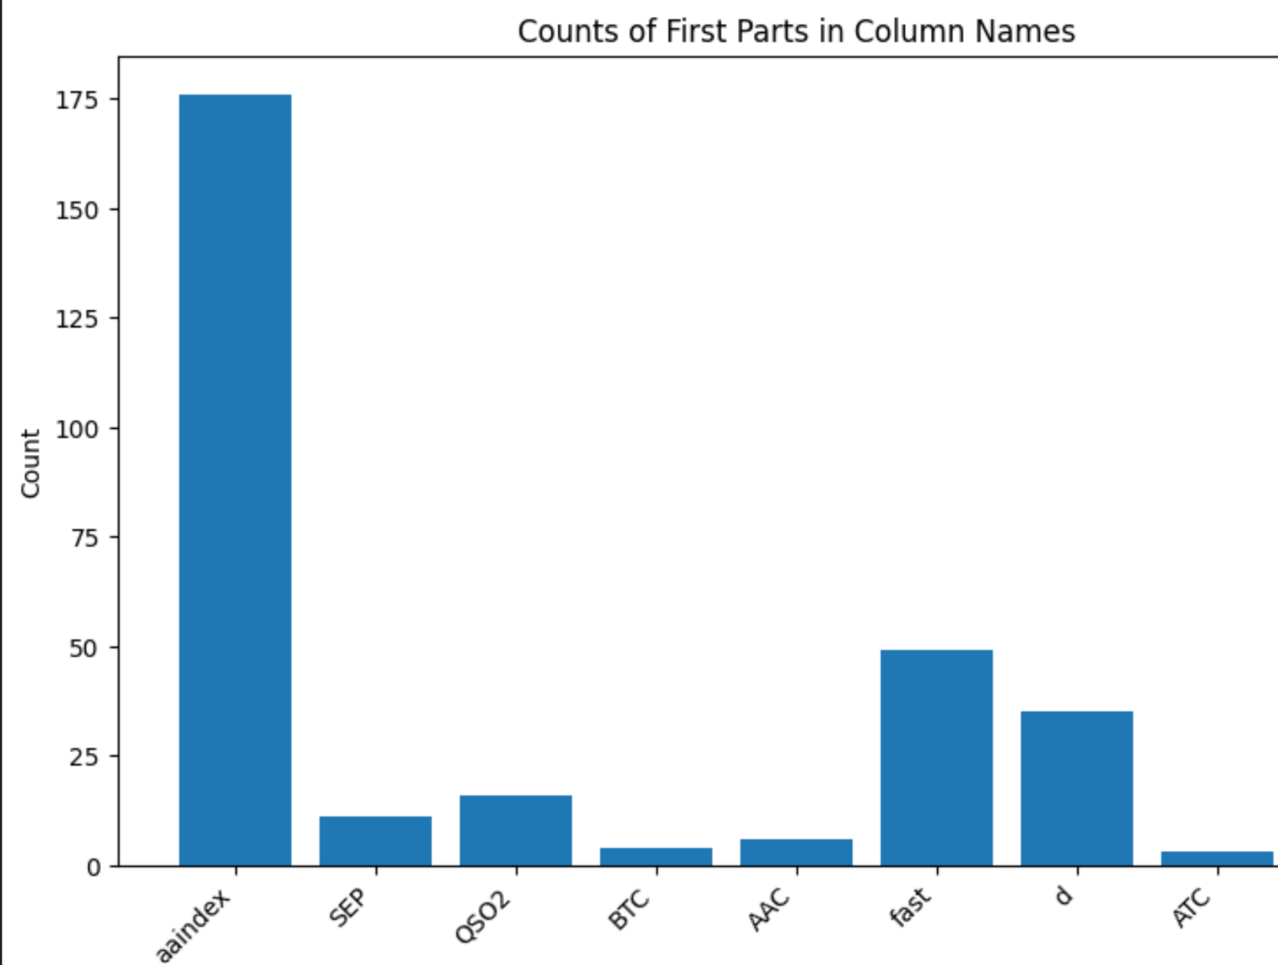

Figure 1: Overview of the Top 300 Selected Features obtained using the Random Forest Feature Selection Method.

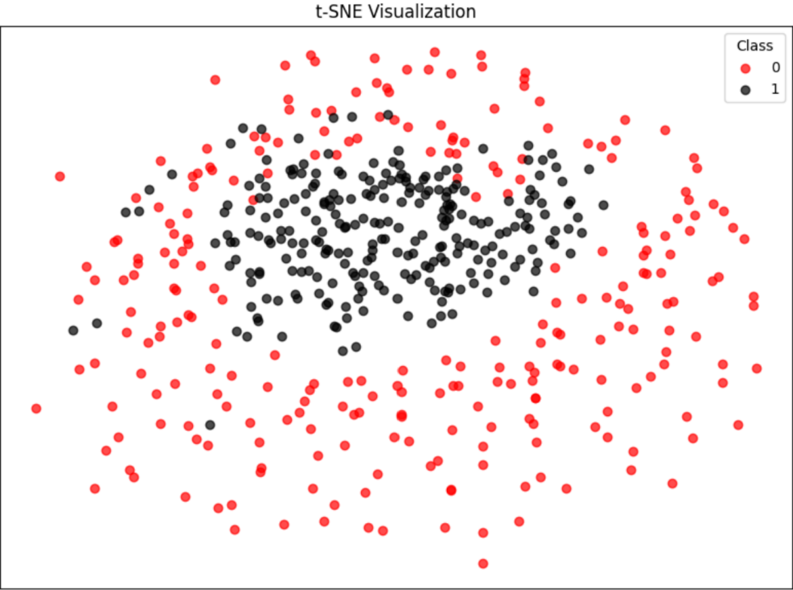

Figure 2: Two-dimensional t-SNE Projection Highlighting Class-wise Clustering on Merged dataset.
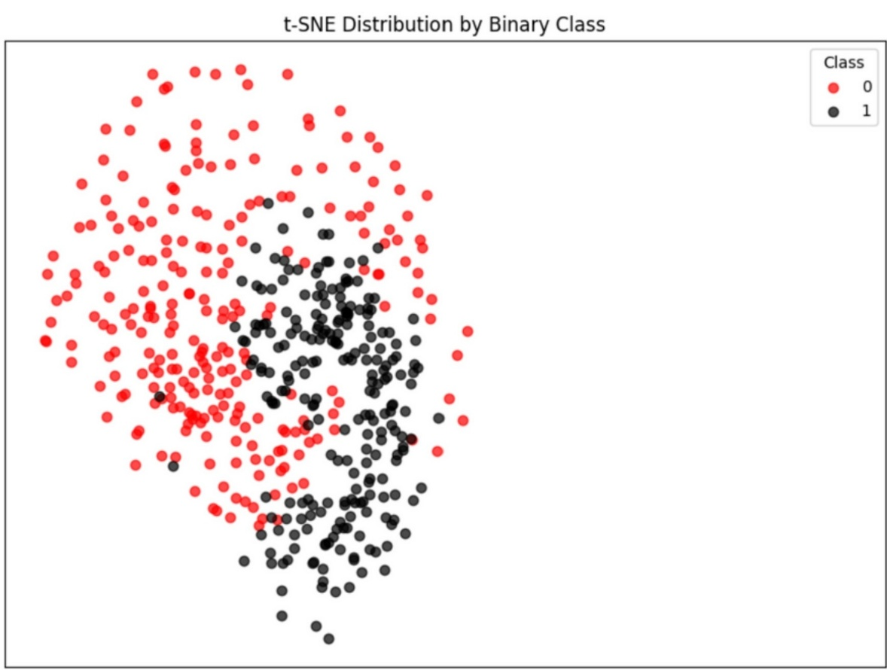

Figure 3. Two-dimensional t-SNE projection illustrating class-wise clustering based on the top 300 selected features.

